DNA

A play by Dennis Kelly, performed by
Emer Halpenny School of Drama's Youth Theatre

Upon arriving at rehearsal, I was met with an electric air, tangible anticipation.
There was a great feeling of community in the room, a sense of belonging from everyone there, along with a clearly visible respect for one another: both as Actors, and friends. It was nice to see it again, I had missed that comradery and friendship, and I found that it was something I’d forgotten since my own acting experiences. It was nice to see some of the people I had worked with in the past, including Billie O’Gorman, and Stuart Gourlay. It was such a long time since I’d seen them act and their abilities as performers were already apparent in years gone by, at this stage they’ve noticeably progressed beyond measure.
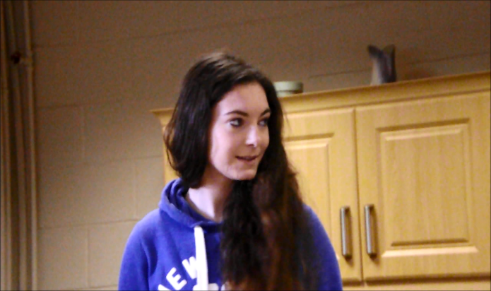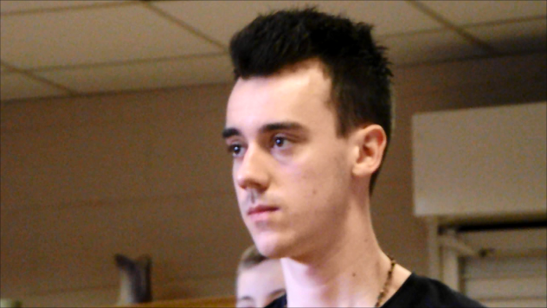

I had no idea what to expect upon arriving. I knew the premise of the play: Bullying. The story within this, however, was to be a definite surprise.
I’ve never seen a play acting out so convincingly, with a cast so genuine and unique. I was almost on the edge of my seat (as clichéd as that sounds, it’s true). I could feel the motion, see that every glance had purpose, and the movements felt so natural and fluid. I felt as if I’d be thrown into this situation and had to watch as all the pieces were put together.
As the story became apparent, I found myself questioning as to what had happened, and what would happen next.
Following the rehearsal, I was lucky enough to get a chance to chat to with Lachlan Kiss (LK) who plays the part of Phil, and Imogen Macaulay (IM) who plays the part of Leah. Imogen and Lachlan have a fantastic chemistry together, and to chat with them was a lovely experience to witness the contrast between their character’s dynamic, and their personal one.
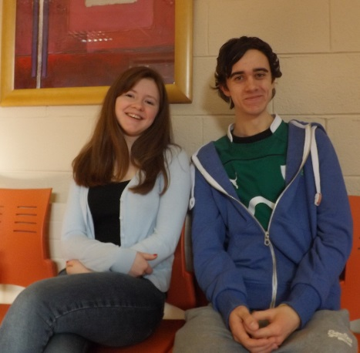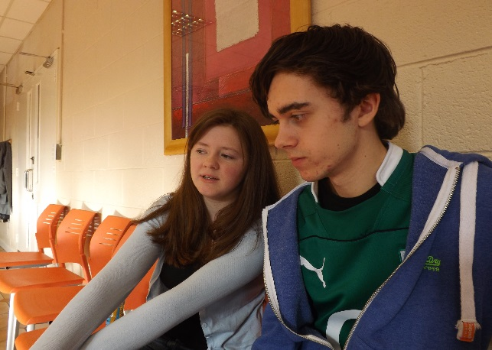
From doing this, do you feel you’ve learned a lot about bullying? In the sense that you view more seriously.
(LK): Yeah, I definitely view it more seriously. In terms of not just what it can do to the person being bullied, but what it can actually do to the person doing the bullying. Obviously this particular thing doesn’t happen a lot but it’s kind of an extreme version of what’s going on.
Did you find it difficult to work through this at any stage? Did you find it kind of difficult, to go through certain scenes?
(IM): I think that some scenes are very hard, especially with the direction?
(LK): Yeah. He’s (Dennis Kelly) very specific with what he wants from the cast.
(IM): The way it’s written can be quite hard to do. My character stops in the middle of her sentences quite a lot and it’s kind of strange to read but you know that he just wants something very clear.
(LK): The part that I found hard, was that she has a lot of monologues where I don’t say anything and I have to stay in this zone of- darkness?
(to LK), I really felt with your performance, and I hope I’m my interpretation of this what you were hoping for, but I was always ready for Phil to snap at Leah. I do hope that’s what you were going for. At all times I was just so ready for him to turn around and snap.
(LK): Well that’s good! It was what I was hoping for, so!

(to IM), with you, and your performance of Leah, I found that the way she- rambles. Was done really well. It didn’t feel like she was an annoying person, but rather, what took place sparked this- defence mechanism within her. Would you agree with that one?
(IM): Ah very good. Hit the nail on the head there!

Considering how good the rehearsal was, the finished production will be something to remember, and I certainly won’t be forgetting it for a long time.
Something this striking and powerful is not to be missed, and I know I can’t wait to see the production on stage.

DNA, is being preformed in St. Laurence’s Community Centre, Stillorgan.
(Beside the Millhouse Pub), on March the 8th at 7pm, and 9th at 6pm.
It is Directed by Emer Halpenny and Co Directed Steward Gourlay.
It stars Anthony Treacy, Billie O'Gorman, Imogen Macaulay, Lachlan Kiss,
Stuart Gourlay, Miles Gaynor, Andrea Byrne, Katie Conroy, Niamh Nutty,
Aneesa Bhamjee, and Aisling Minogue.
- Jack Sperin

